Processor Organization
Central Processing Unit: The part of the computer that performs the bulk of data processing operations is called the central processing unit and is referred to as the CPU.
The CPU is made up of three major parts as shown in fig 8-1.
- The register set stores intermediate data used during the execution of the instructions.
- The arithmetic logic unit (ALU) performs the required microoperations for executing the instructions.
- The control unit supervises the transfer of information among the registers and instructs the ALU as to which operation to perform.
General Register Organization
As memory access is the most time-consuming operation in a computer. It is more convenient and more efficient to store intermediate values in processor registers. When a large number of registers are included in the CPU, it is most efficient to connect them through a common bus system.
A bus organization for seven CPU registers
A bus organization for seven CPU registers is shown in fig 8-2.
The output of each register is connected to two multiplexers (MUX) to form the two buses A and B.
The selection lines in each multiplexer select one register or the input data for the particular bus.
The A and B buses form the inputs to a common arithmetic logic unit (ALU). The operation selected in the ALU determines the arithmetic or logic microoperation that is to be performed.
The result of the microoperation is available for output data and also goes into the inputs of all the registers. The register that receives the information from the output bus is selected by a decoder. The decoder activates one of the register load inputs, thus providing a transfer path between the data in the output bus and the inputs of the selected destination register.
The control unit that operates the CPU bus system directs the information flow through the registers and ALU by selecting the various components in the system.
EXAMPLE:
• To perform the operation R1 R2+R3
The control must provide binary selection variables to the following selector inputs:
1. MUX A selector (SELA): To place the content of R2 into bus A.
2. MUX B selector (SELB): to place the contents of R3 into bus B
3. ALU Operation selector (OPR): to provide the arithmetic addition A+B
4. Decoder destination selector (SELD): to transfer the content of the output bus into R1.
The four control selection variables are generated in the control unit and must be available at the beginning of a clock cycle. The data from two source registers propagate through the gates in the multiplexers and the ALU, to the output bus, and into the inputs of the destination register, all during the clock cycle interval. When the next clock transition occurs, the binary information from the output bus is transferred into R1.
CONTROL WORD
• There are 14 binary selection inputs in the unit and their combined value specifies a “control word”.
• It consists of four fields. Three fields contain three bits each, and one field has five bits.
FORMAT OF CONTROL WORD
SELA | SELB | SELD | SELOPR

1. The three bits of SELA select a source registers for the A input of the ALU.
2. The three bits of SELB select a source registers for the B input of the ALU.
3. The three bits of SELD select a destination register using the decoder.
4. The five bits of OPR select one of the operations in the ALU.
Register and multiplexer input selection code
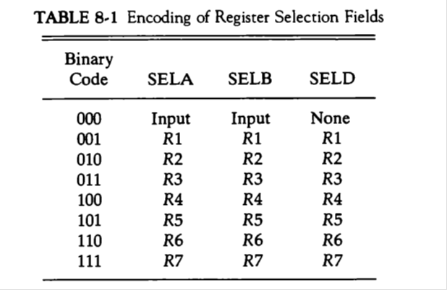
When SELA or SELB is 000, the corresponding multiplexer selects the external input data. When SELD =000, no destination register is selected but the contents of the output bus are available in the external output.
Operation with symbol
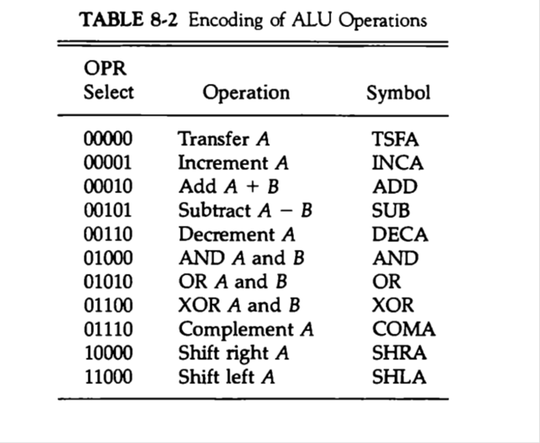
Examples of Microoperations
A control word of 14 bits is needed to specify a microoperation in the CPU. The control word for a given microoperation can be derived from the selection variables.
For example, the subtract microoperation given by the statement
R1 R2-R3
Specifies R2 for the A input of the ALU, R3 for the B input of the ALU, R1 for the destination register and an ALU operation to subtract A - B.
The binary control word for the above subtract microoperation is 010 011 001 00101 and is obtained as follows:
Field: SELA SELB SELD OPR
Symbol: R2 R3 R1 SUB
Control word: 010 011 001 00101

